Breakfast

German Breakfast

Bread, butter, jam, egg, fruit,

Salami, Schinken or Cheese Php. 310.-

mug coffee or tea

Simple Breakfast

Bread, butter, jam and egg Php. 185.-

Fruit, mug coffee or tea

Special Breakfast

Cornflakes w/milk, bread, butter

jam, egg, fruit, Salami, Schinken

mug coffee or tea Php. 375.-

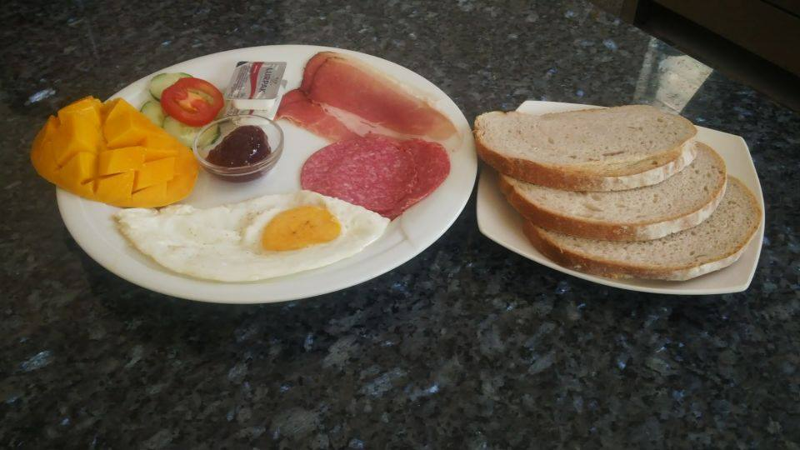

* + 1. German Breakfast

Breakfast

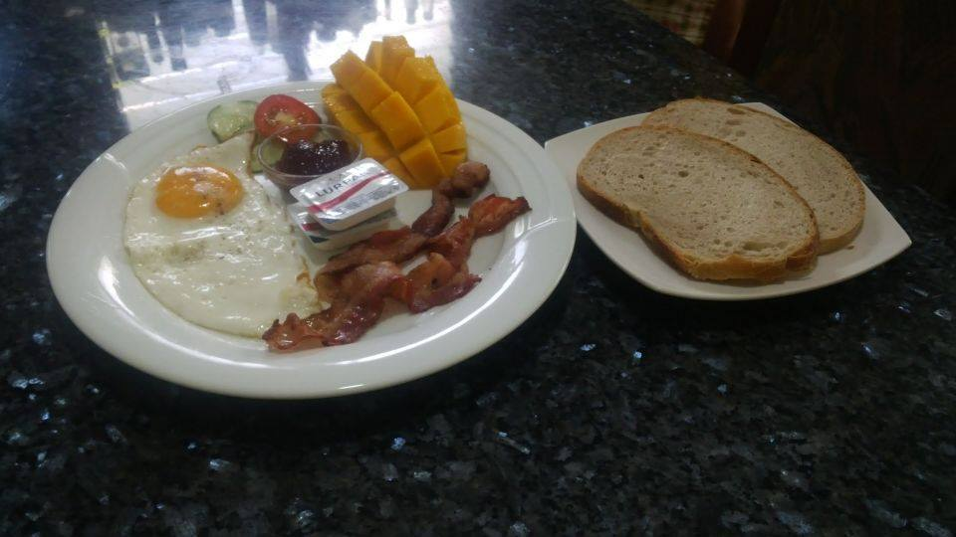 American breakfast

Continental Breakfast

Bread, butter, jam, fruit

cup coffee or tea Php. 110.-

American Breakfast

Bread, butter, jam, fruit,

Egg, bacon or ham

mug coffee or tea Php. 250.-

Filipino Breakfast

Garlic or plain rice, egg,

fruit, ham or bacon, Php. 185.-

Langoniza

Mug coffee or tea

Soup

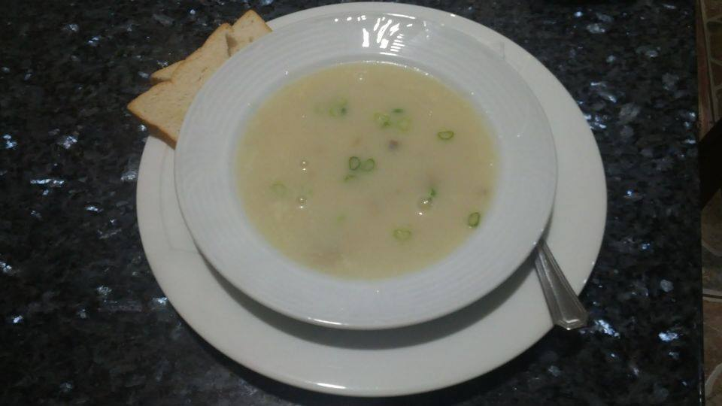 Asparagus cream soup

Asparagus cream soup Php. 85.-

Mushroom cream soup Php. 85.-

Corn cream soup Php. 85.-

Tomato cream soup Php. 95.-

Salad

Mixed vegetable salad Php. 125.-

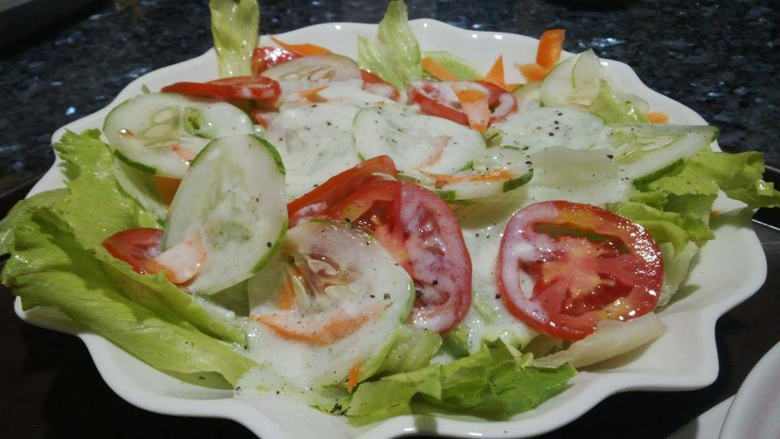Tomato salad Php. 110.-

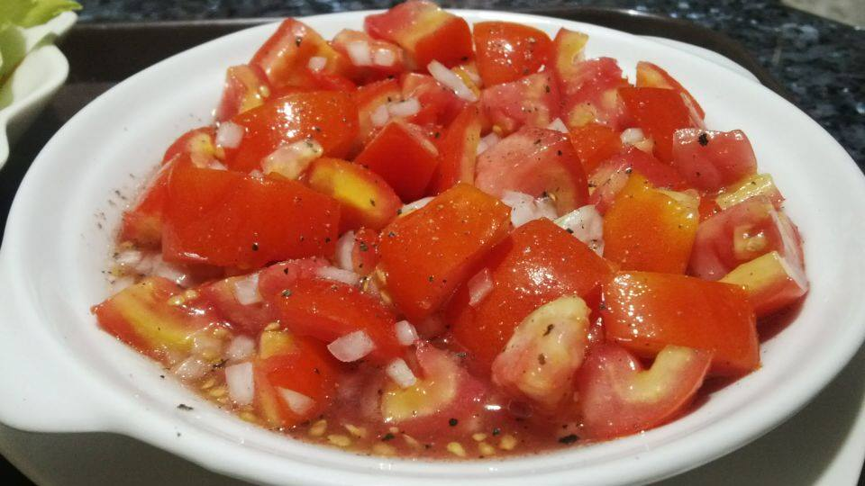

Mixed Vegetable salad Tomato salad

Sandwiches

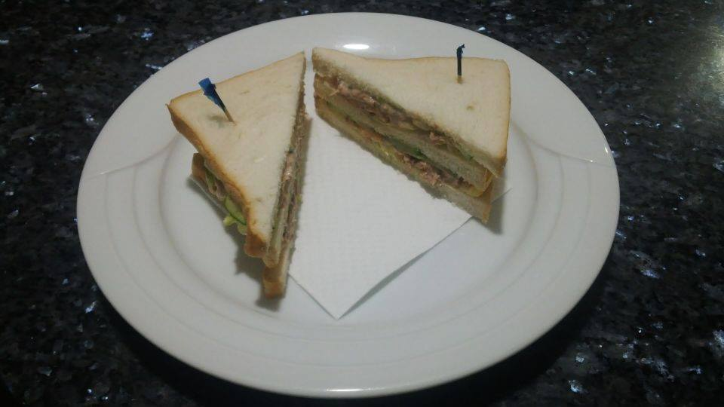Tuna sandwich

Sandwich w/bacon Php. 119.-

Sandwich w/ ham Php. 110.-

Sandwich w/ham and cheese Php. 135.-

Sandwich w/egg Php. 75.-

Clubhouse sandwich Php. 250.-

Baguette w/salami

or schinken Php. 175.-

Sandwich w/ tuna Php. 110.-

Omelette

Mushroom Php. 95.-

Bacon Php. 138.-

Ham Php. 128.-

Cheese Php. 95.-

Corned beef Php. 115.-

Ham and bacon Php. 159.-

Ham or bacon w/ cheese Php. 170.-

Asparagus Php. 90.-

Ham, bacon and cheese Php. 195.-

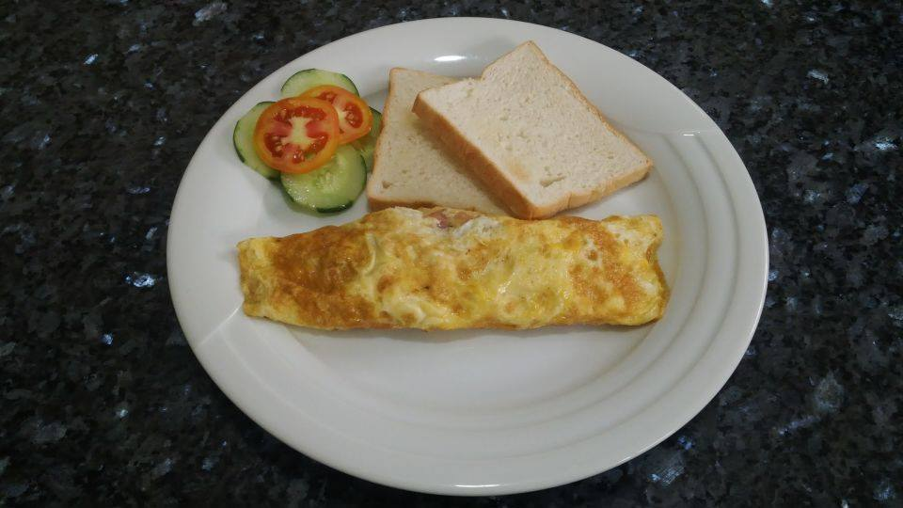

Cheese omelette

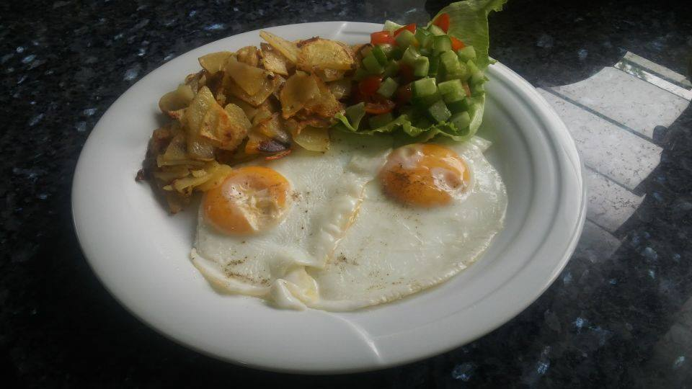Menu

Fried Potato w/ eggs

Lumpia Shanghai Php. 175.-

Chopsuey Php. 188.-

Pancit Canton Php. 185.-

Fried Potato w/eggs Php. 230.-

Boiled potato, Spinach and eggs

( Salzkartoffel, Spinat und Eier ) Php. 250.-

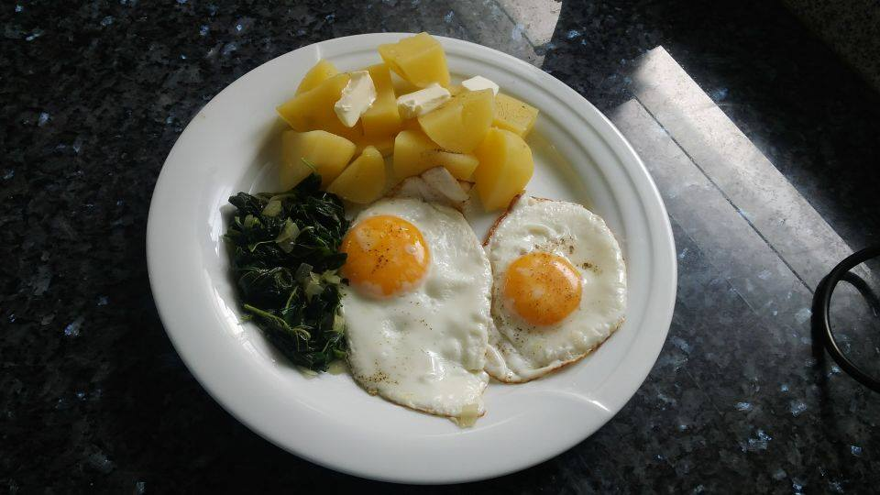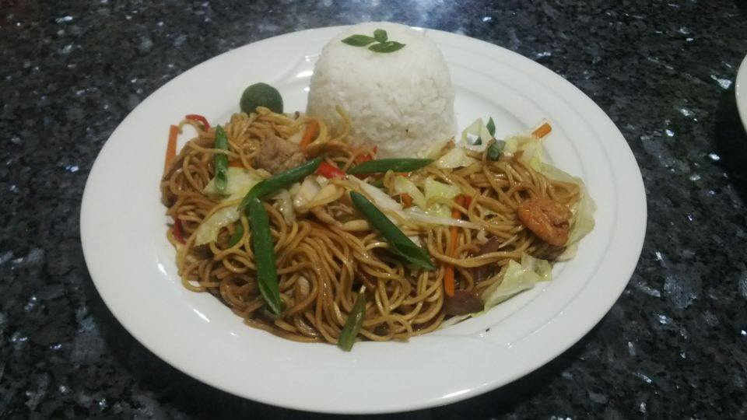Pancit canton w/ rice Boiled Potato w/ spinach and

eggs